# DALUBHASAAN NG LUNGSOD NG LUCENA

(formerly City College of Lucena)

**ITPS308 – Final Output**

**FullName** : **Jerwin Nico H. Quijano** **Date : 11/26/2025 Section: BSIT-3B**

**FINAL OUTPUT INSTRUCTION: CISCO NETACAD INTRODUCTION TO CYBERSECURITY CERTIFICATION (ITPS308)**

1. **OVERVIEW AND OBJECTIVE**

This output will serve as final output in our subject ITPS308 , if some of you already finish this module better . you only need to take the screenshot and make it in the format of our final output . This task is designed to ensure you possess a foundational understanding of critical cybersecurity concepts, a mandatory skill set in the modern IT landscape.

Link : [**https://www.netacad.com/courses/introduction-to-cybersecurity?courseLang=en-US**](https://www.netacad.com/courses/introduction-to-cybersecurity?courseLang=en-US)

1. **REQUIRED or Needed to be done or to do :**

**Your final submission must be compiled into one single, PDF document. This document must contain four (4) mandatory components that strictly adhere to the following criteria:**

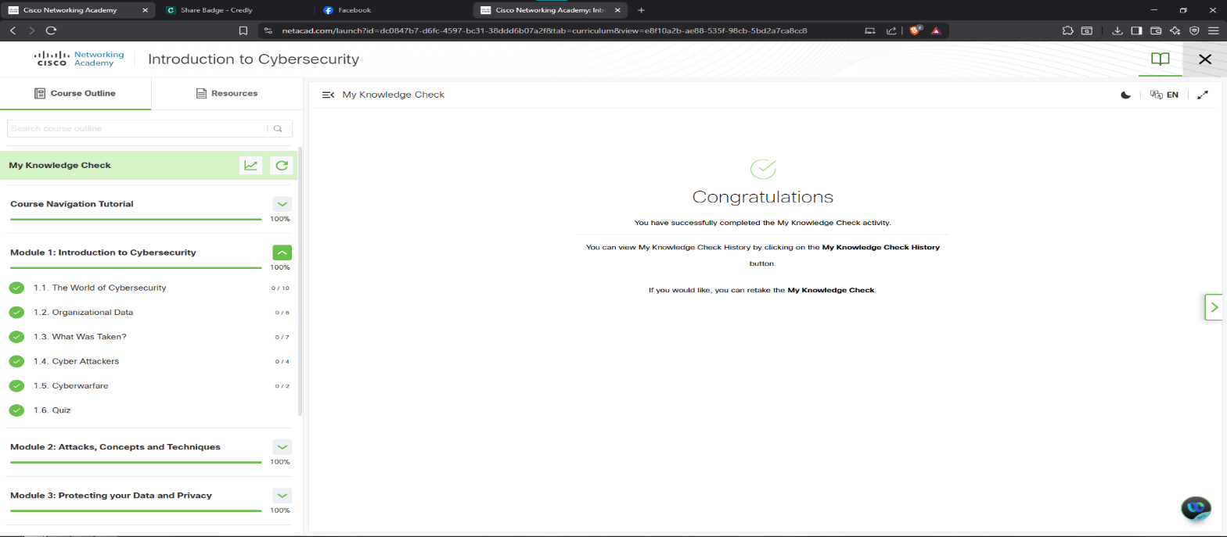**Module 1:**

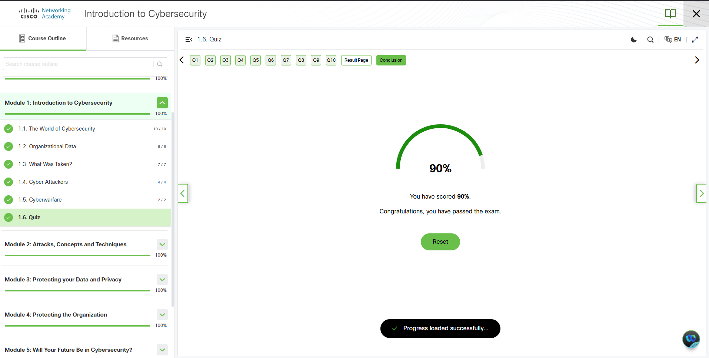

**Module 1:**

* **Least Privilege** means people only get access to what they really need for their job.
* **Defense-in-Depth** is about having multiple security layers so if one fails, others still protect you.
* **CIA Triad** are the main goals of security: keeping info private (Confidentiality), accurate (Integrity), and available when needed (Availability).

**Module 2:**

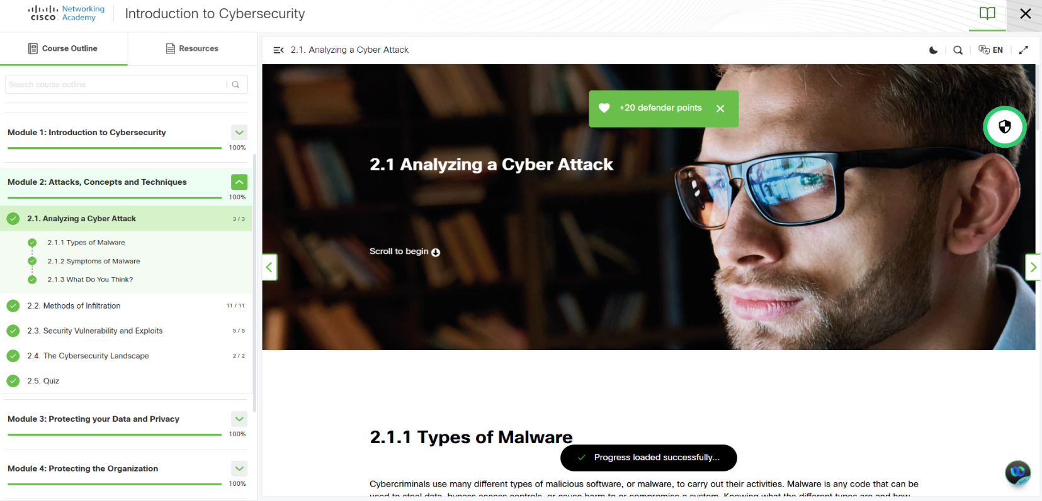

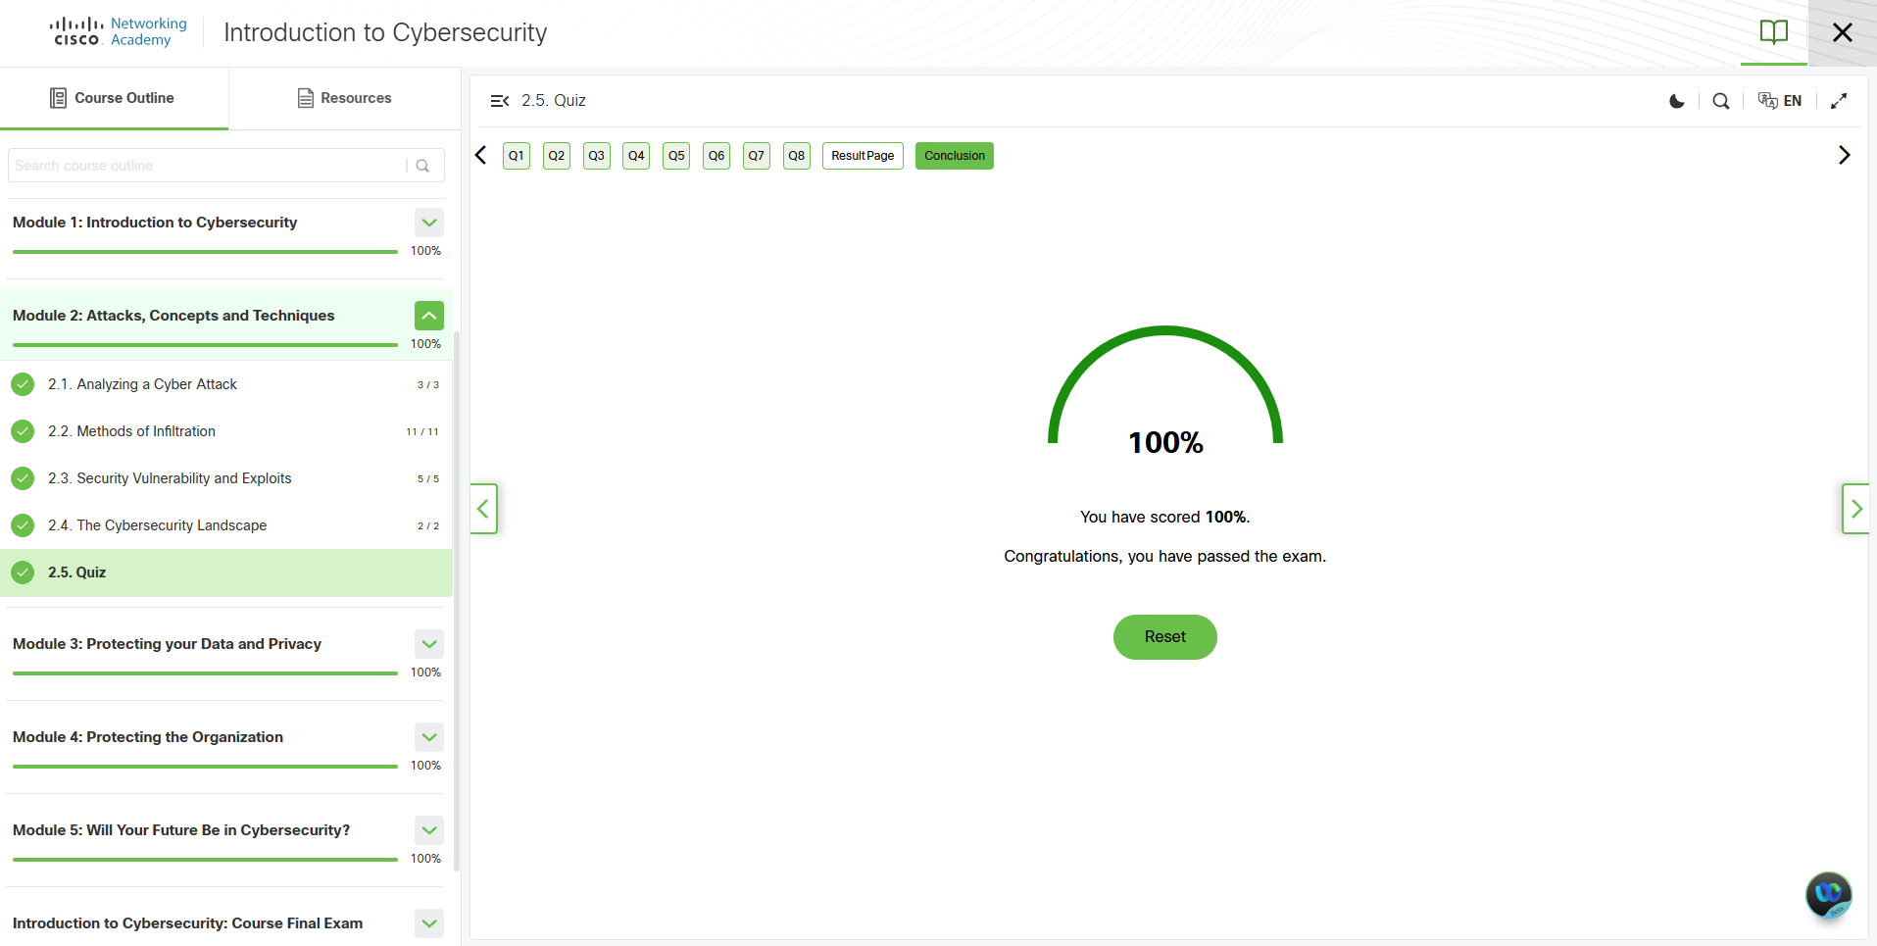

* **Vulnerabilities:** flaws like buffer overflows, bad input, race conditions, weak security practices, or poor access control can let attackers crash systems or steal data.
* **Updates:** regularly patch software to fix known vulnerabilities and reduce risk.
* **Proactive security:** use testing, penetration tests, and security research (e.g., Google’s Project Zero) to find and fix issues before attackers exploit them.

Module 3:

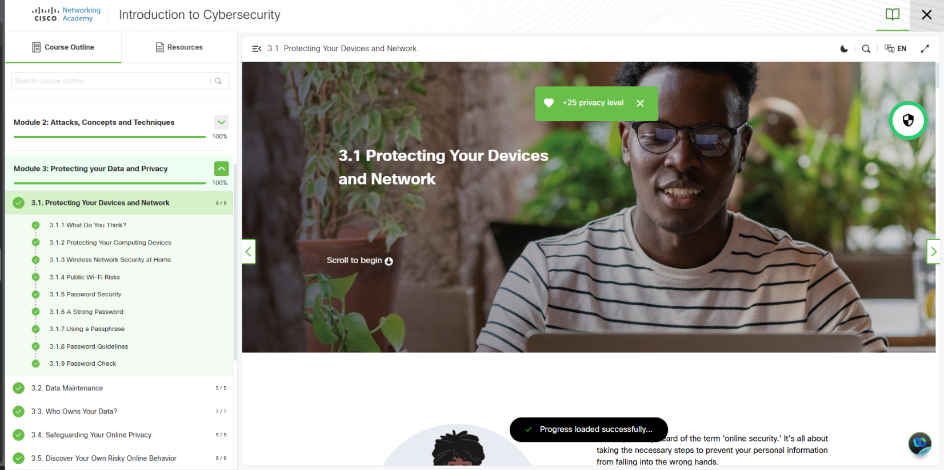

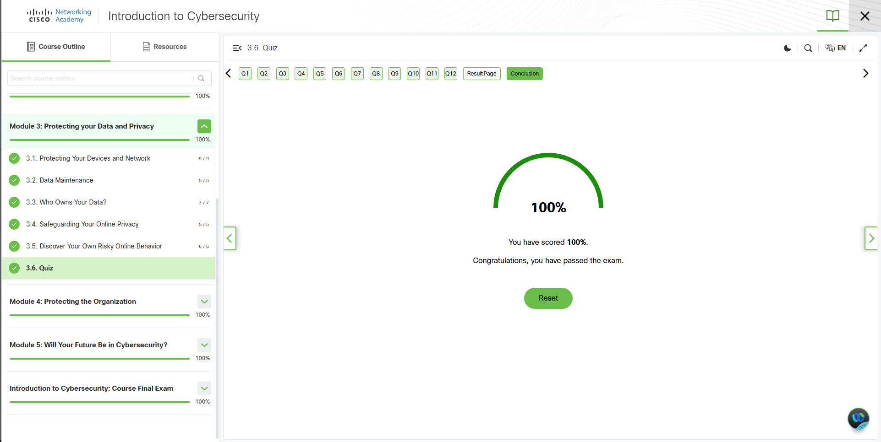

* **Terms of Service:** it’s a contract that sets the rules between you and the service, telling you what you can and can’t do.
* **Data Use Policy:** you still own your stuff, but the company can use or share it depending on their rules.
* **Privacy Settings:** by default, your info might be visible to everyone, so you need to adjust settings if you want more privacy.

Module 4:

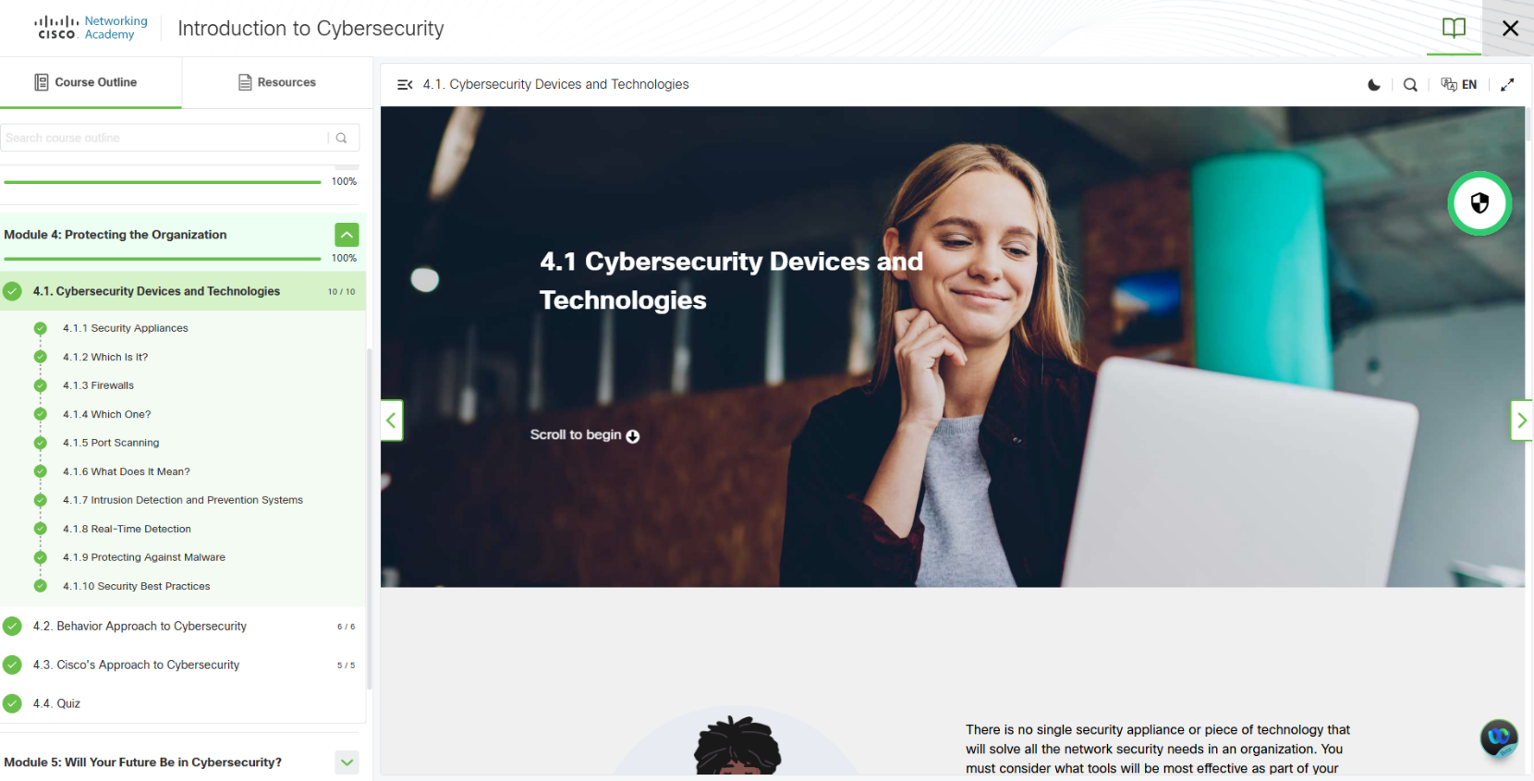

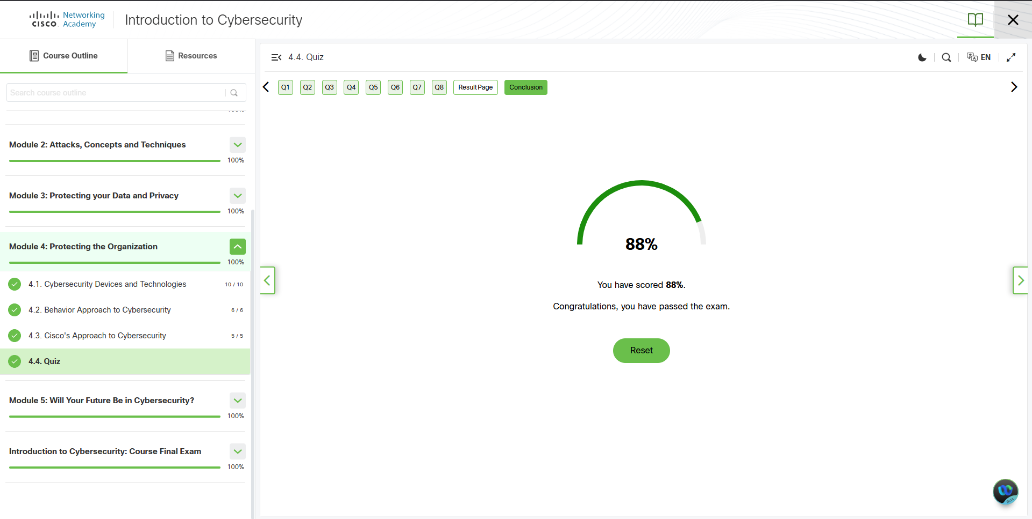

* **Behavior-Based Security & Detection:** tools like honeypots and NetFlow watch for unusual activity on the network. Anything that deviates from normal behavior could be an attack.
* **Penetration Testing (Pen Test):** simulate attacks in steps—plan, scan, gain access, maintain access, and report findings—to uncover vulnerabilities and improve defenses.
* **Risk & Impact Management:** no system is perfect. Be ready to respond quickly to breaches, communicate clearly, find the cause, learn lessons, and manage risk by assessing threats, their impact, and taking actions to reduce or monitor them.

Module 5:

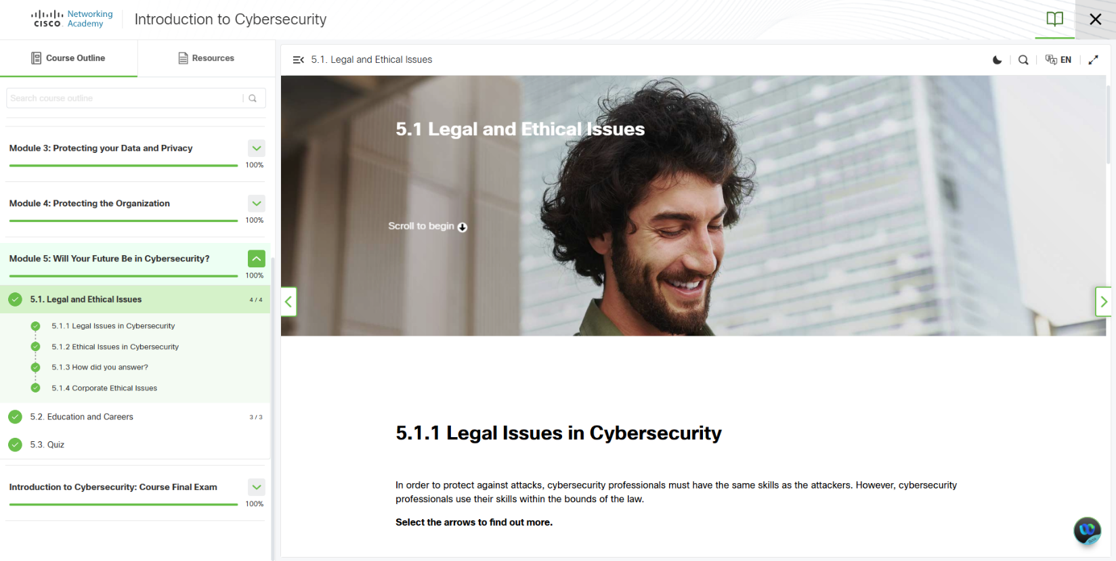

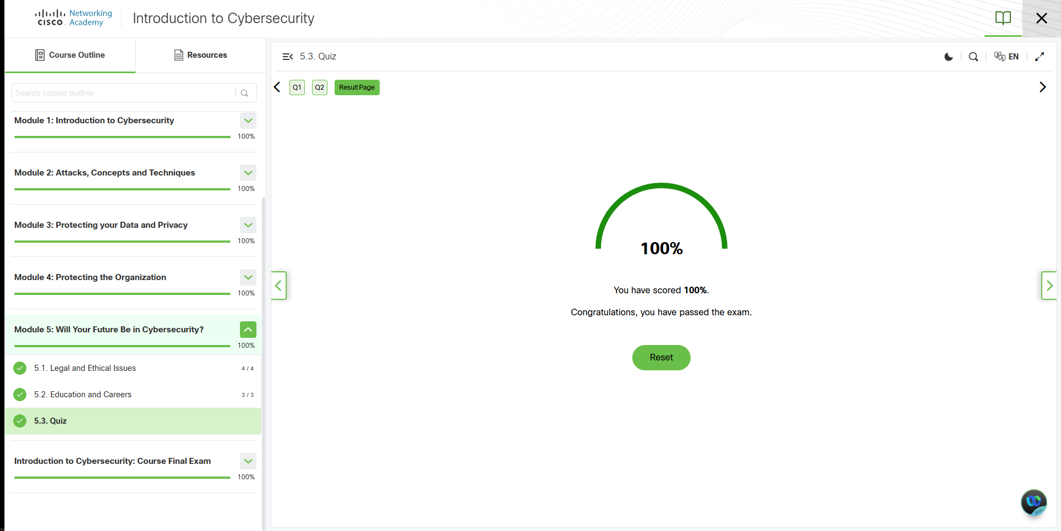

* **Legal & Ethical Stuff:** use your hacking skills legally and responsibly. Just because it’s not illegal doesn’t mean it’s the right thing—always be honest and report anything important.
* **Company Ethics:** big companies and organizations like ISSA or Cisco have codes of ethics to help you make the right choices at work.
* **Career & Certs:** start checking out cybersecurity jobs early. Getting certs like CCST, Security+, CEH, CISSP, or CyberOps Associate can show your skills and help you grow. Tools like CyberSeek can show job paths, salaries, and skills you need.

Course Final Exam Score and Certificattion:

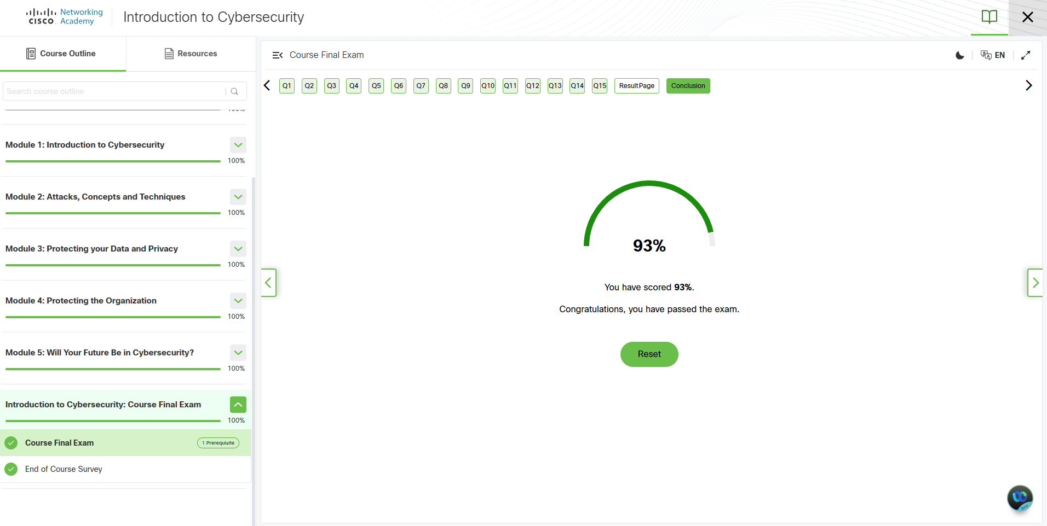

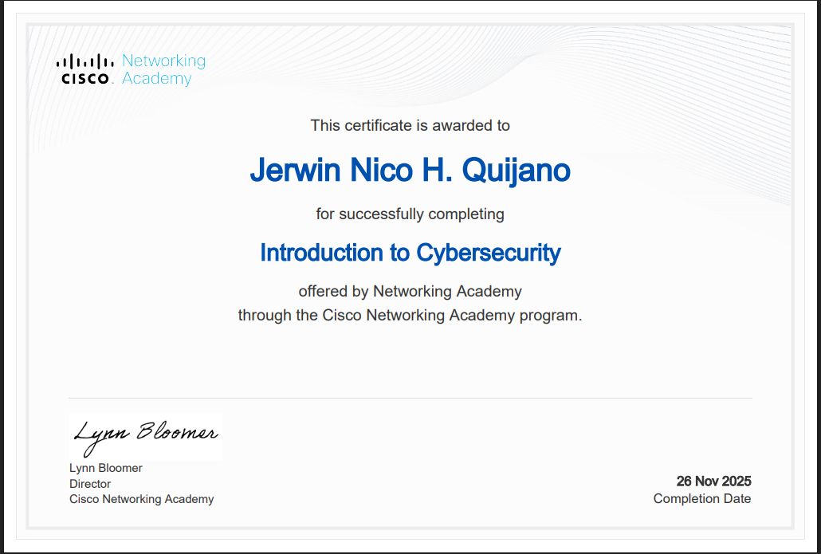

# DALUBHASAAN NG LUNGSOD NG LUCENA

(formerly City College of Lucena)

**ITPS308 – Final Output**

**IV. SUBMISSION DOCUMENT FORMATTING GUIDE**

The final PDF file MUST be named exactly as follows: ITPS308_FinalOutput_Cybersecurity_[YourLastName]_[YourFirstName].pdf

**V. FINAL CHECKLIST AND GRADING SUCCESS**

**Before submission, use this checklist to ensure you meet all requirements for a passing grade:**

|  |  |  |
| --- | --- | --- |
| **Requirement** | **Status (Y/N)** | **Points Weight** |
| Completed all necessary readings/activities? | Y | - |
| Certificate of Completion included? | Y | 40% |
| 100% Completion screenshot for *every* module? | Y | 30% |
| Quiz Score ≥ 80% screenshot for *every* module quiz? | Y | 20% |
| 2-4 Key Takeaways included for *every* module? | Y | 10% |
| Total Compliance | 100% | 100% |